DataSoft

Nova Security Appliance Quick-Start Guide

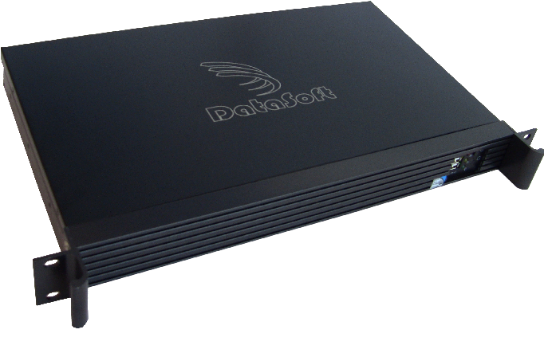

Contacts

DataSoft Corporation
1275 W. Washington Street
Suite 106
Tempe, AZ 85281

Technical Support

Phone: (480) 763-5777
Email: nova@datasoft.com
Website: www.projectnova.org

Product Components
What's in the box:
- Nova Security Appliance
- Quick-Start Guide (This document)
- CD Containing Nova Appliance User's Manual
- Sheet containing initial username/passwords, MAC addresses
- Power Cord
- Mounting Brackets and Screws

Setting-up and Connecting Nova Security Appliance

- Unwrap the Nova Security Appliance and take out mounting screws from the box.
- Mount and securely screw the Nova Security Appliance into place.
*Note: Make sure to tightly screw the Nova Security Appliance brackets to the rack and that the Nova Security Appliance is secure.
- Plug-in the power cord and Ethernet cables.
*Note: Make sure to record which port number (printed on the top of the appliance) each Ethernet cable was initially plugged into. Nova will by default attempt to obtain an IP address via DHCP when powered on. If you wish to provide it with a static IP address, make note of the MAC addresses and register them with your DHCP server.
- Turn the Nova Security Appliance on by pushing the power button.
- Visit the Nova Web UI (called Quasar) in Firefox or Chrome web browsers:

https://APPLIANCE_IP_ADDRESS:8080

Where “APPLIANCE_IP_ADDRESS” is the address obtained via DHCP. (If it is impossible to know what address is obtained, a serial port on the rear of the Appliance is provided)
- Continue with initial configuration by following the steps in the Quick Setup Wizard which appears on screen and in the Nova Appliance User's Manual.

